Experiment 4
Create a scientific calculator using Bash
Done By: Rohit Karunakaran

Program Code:

#! /bin/bash
#Created by Rohit Karunakaran

show_help()
{
echo "
Scientific calcualtor implementaion using bash.
Enter 'help' to show this menu.
Enter quit to exit

a+b Add a and b
a-b Subtract b from a
a*b Multiply a and b
a/b Divide a and b
a^b Exponential, Raise a to the power of b
a%b Modulo operation, Remainder of a/b

s(x) sine of x, x is in radians
c(x) cosine of x, x in radians
l(x) natural log of x
e(x) raise e to the power of x
sqrt(x) Find the square root of x"
}

calculate(){
if [[ $1 = *'%'* ]]
then
scale=0
echo "scale=${scale};${1}" | bc -l -q
else
scale=4
echo "scale=${scale};${1}" | bc -l -q | awk '{printf "%.4f", $0}'
echo ""
fi
}

show_help

echo -n "Sci_calculator>> "

while read command
do
case $command
in
quit|exit) exit 0 ;;
help) show_help ;;
*) calculate $command ;;
esac

echo -n "Sci_calculator>> "
done

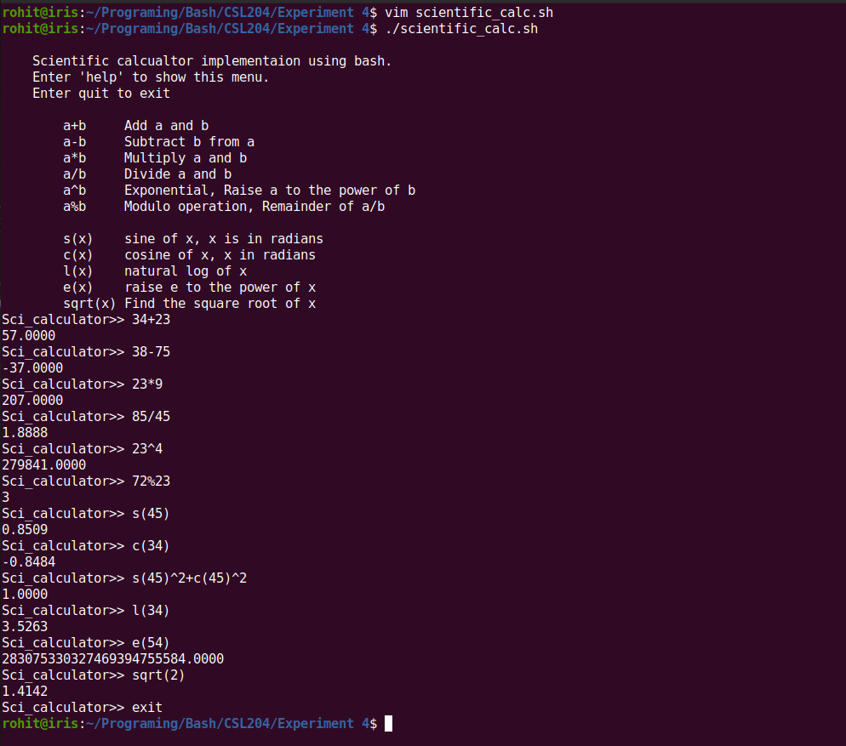
Screenshots:

